

network access

Introduction to Networking and Security



October 6, 2019

Jamie lu

W0441213

Table of Contents

Introduction: 2

Chapter 4 Network Access 3

4.2.4.4 Connecting a Wired and Wireless LAN 3

Part 4: Verify Connections 3

Screenshot of Part 4 Step 1A: Pinging netacad.pka from Family PC 3

Part 4 Step 2: Getting the IP Address of the Switch 5

Part 4 Step 3: Viewing Interface Statuses 7

Questions 8

4.2.2.7 Building an Ethernet Crossover Cable 9

Straight-through Cables VS. Crossover Cables 9

• What are the differences? 9

• What role does the different cable pairs play in each cable? 9

• When you would use each? 9

Ways why attenuation can be minimized in copper media and why it’s not a problem with fiber. 10

Wireless Transmission Technologies 11

Narrowband 11

Broadband 11

Spread-Spectrum 11

Activity 4 – Network Media 13

Screenshots 13

Screenshot 1 of Activity 4 – Network Media Completion 13

Screenshot 2 of Activity 4 – Network Media Assessment Items 14

Screenshot 3 of Activity 4 – Network Media Assessment Items 15

Reflection: 16

Do you know the difference between a physical topology and a logical topology? How are each used? How would you view each topology in Packet Tracer? 16

References 17

# Introduction:

This assignment contains activities that used learnings from Cisco’s CCNA R&S: Introduction to Networking: Chapters 4[1]. This assignment also contains the continuation of the case study from the previous assignments, with this one being Network Media. The mentioned case study focuses on the knowledge and skills that are required to create a custom UTP cable. This assignment also contains information on the different types of wireless transmission technologies, ethernet cabling, and using different topologies.

# Chapter 4 Network Access

## 4.2.4.4 Connecting a Wired and Wireless LAN

## Part 4: Verify Connections

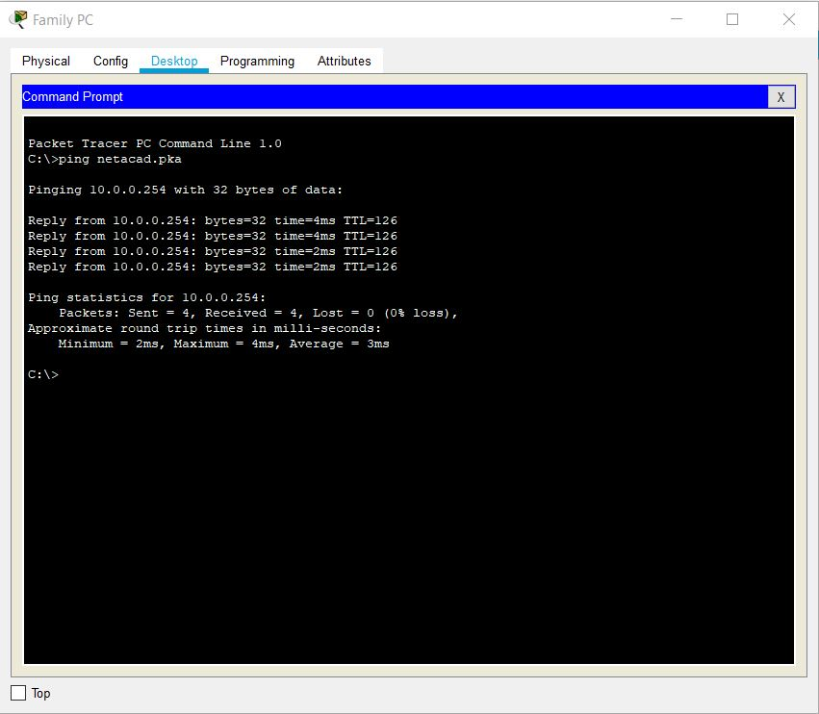

### Screenshot of Part 4 Step 1A: Pinging netacad.pka from Family PC

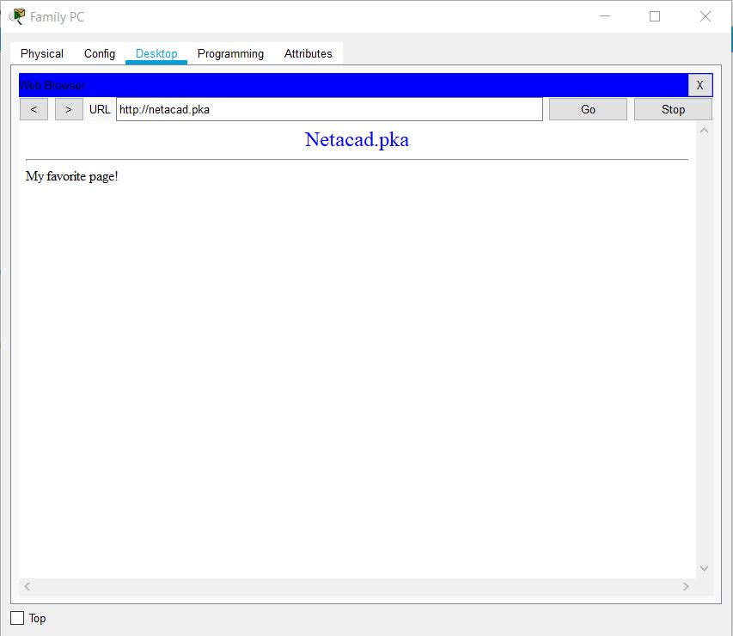Screenshot of Part 4 Step 1B: Opening netacad.pka on the web browser

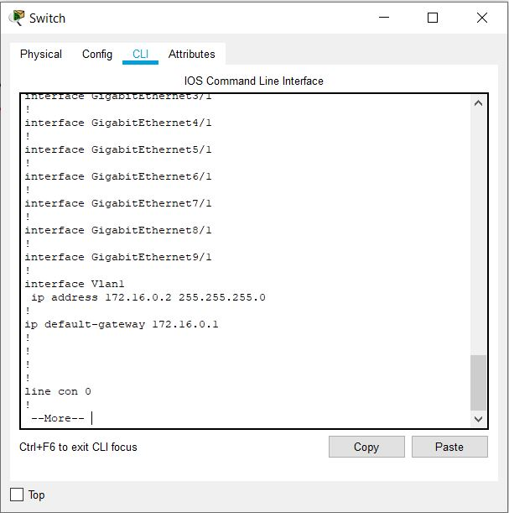

### Part 4 Step 2: Getting the IP Address of the Switch

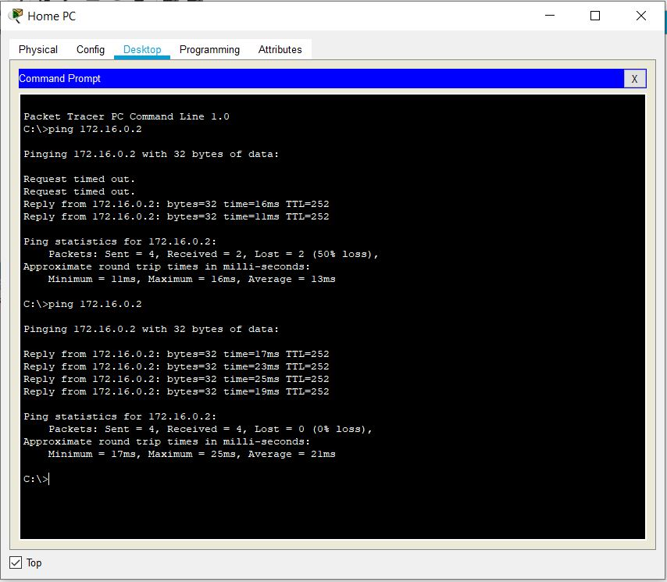Part 4 Step 2: Pinging the switch from the Home PC

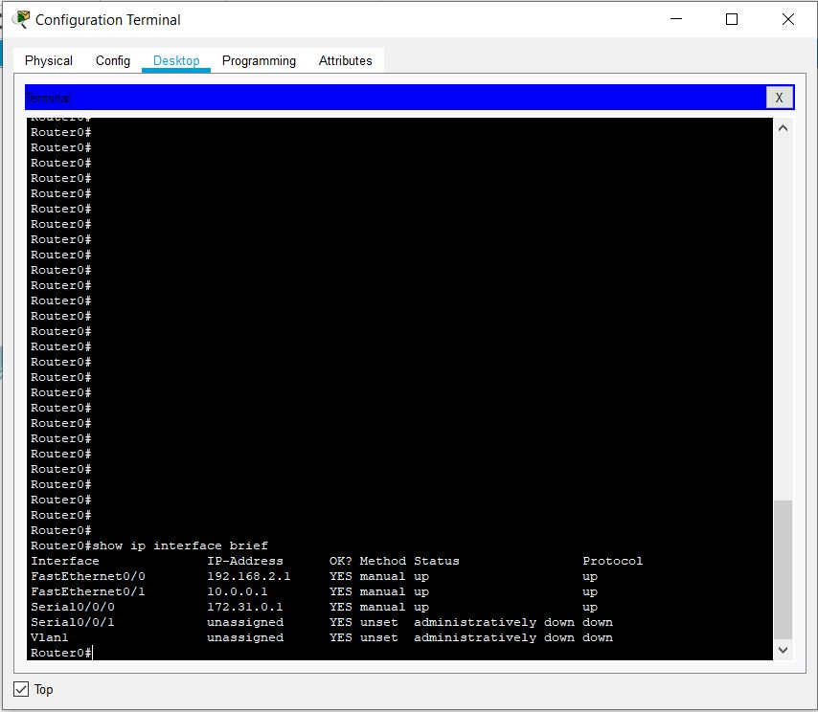

### Part 4 Step 3: Viewing Interface Statuses

### Questions

**Step 2:**     **Examine the Primary Network.**

a.     Click the **Primary Network** icon. Hold the mouse pointer over the various cables. What is located on the table to the right of the blue rack?

- The Configuration terminal is located on the table.

**Step 3:**     **Examine the Secondary Network.**

a.     Click the **Secondary Network** icon. Hold the mouse pointer over the various cables. Why are there two orange cables connected to each device?

- The orange cables connected to each device are called fiber cables that come in pairs. One fiber cable is used for transmitting data and the other one is for receiving data.

**Step 4:**     **Examine the Home Network.**

a.     Why is there an oval mesh covering the home network?

- The oval mesh covering the home network shows the wireless grid or the range of the wireless network.

b.    Click the **Home Network** icon. Why is there no rack to hold the equipment?

- There is no rack to hold the equipment because this is the home environment. Home networks usually don’t have racks. The different devices are usually stored in different places depending on the owners.

## 4.2.2.7 Building an Ethernet Crossover Cable[2]

### Straight-through Cables VS. Crossover Cables

### What are the differences?

* The straight-through and crossover cables are both types of UTP (Unshielded Twisted-Pair) cable. One difference between both cables is the way their connectors are wired on each end. The straight-through cable is wired with both ends using either T568A wiring standard or T568B wiring standard.
* Another difference that they have is the devices that they connect to. The straight-through cables can connect two different types devices, whereas, crossover cables are usually used to connect the same kind of devices. Straight-through devices are also usually used in local area networks in order to connect a computer to a router or other network hubs. Crossover cables, on the other hand, are usually used to directly connect two computing devices.
* The straight-through cable also has a different wiring standard from the crossover cable. For straight-through cables, the wired pins match and they use one wiring standard where either T568A wiring standard or T568B is used on both ends. For crossover cables, however, each end has a different standard. For example, one end can have the T568A standard and other a T568B standard.

### What role does the different cable pairs play in each cable?

* The different cable pairs do not play any role in straight-through cables because they have the same wiring standard on both ends, either T568A or T568B. In the crossover cables, however, crossover cables have different cable pairs in wiring. The different cable pairs reverse the transmit and receive signals.

### When you would use each?

* Straight-through cables are primarily used to connect devices that are different. They are commonly used when one is connecting network client devices to a host device. For example, connecting a computer or printer to a router.
* Crossover cables are usually used to connect like devices. They are commonly used to directly connect computing devices together. For example, connecting computer A with computer B using NICs or connecting switch A with switch B.

## Ways why attenuation can be minimized in copper media and why it’s not a problem with fiber.[3]

- Attenuation is the term used when there is loss of transmission signal strength. The more attenuation there is, the more distorted the transmission will be. There are ways to minimize attenuation in copper media, one of which is to do cable shielding. Cable shielding is a common method to avoid interference because this method involves placing a shield around the conductors. Another way to minimize attenuation in copper media is by using a network repeater device to amplify the signal. This will electrically increase the strength of a line signal. In addition to the device, one can also add antennas to boost signals.

- Fiber is immune to interference from electromagnetic signals because of the characteristics of fiber. Fiber signals travel in tiny glass tubes wherein these tubes contain wavelengths of light that carries data from the source to the destination, and light travels a lot faster than electromagnetic waves. Therefore, it does not suffer attenuation. Light also resists other sources of noise that can cause attenuation, such as electricity and radio frequencies, that is why attenuation is not a problem with fiber.

## Wireless Transmission Technologies

### Narrowband[4]

- Narrowband is a channel wherein the message bandwidth is considered flat. It has less bandwidth than the coherence bandwidth. This is because it has lesser amount of frequency sets. In telecommunication technologies, voice data is carried on a limited number of frequency sets using narrowband. Narrowband is advantageous because it has lower noise bandwidth which means it has better sensitivity and a better range.

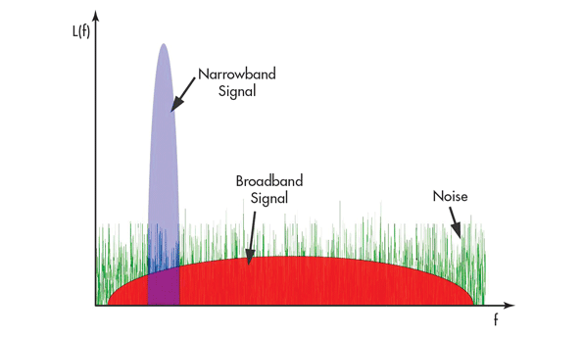

Image that shows the difference of Narrowband Vs. Broadband

Photo from (DeLisle, 2014)

### Broadband[5]

- Broadband is a wide bandwidth data transmission. It is most commonly used form of internet access, this is because of the speed that broadband has. Broadband has high access speeds that is offered in multiple mediums, coaxial cable, optical fiber, radio or twisted pair. Broadband has a wide band of frequencies. With broadband, data can be multiplexed[6] and sent on a lot of channels. This procedure will allow the transmission of data any time. In broadband, a single medium is able to carry multiple channels at once. Examples of devices that use broadband are laptops and cable TVs.

### Spread-Spectrum[7]

- Spread-spectrum is another way to transmit radio or telecommunications signals. This technique transmits a signal on a bandwidth that is larger than the frequency. The frequency of the transmitted signal using spread-spectrum is varied and this results in greater the bandwidth. This technique is helpful in different ways. A couple of examples is that using spread-spectrum helps in resisting interference, and it has anti-jamming effects. It also has another helpful benefit, it is also helpful in establishing the security of communications, this is because of spread-spectrum’s resistance to interception. Nonauthorized listeners cannot decode the original sign because they would not have the key used to spread the it. Without this key, these unauthorized listeners would just appear as noise or interference. In applying spread-spectrum, one has to “simply inject the spread-spectrum code in the transmitting chain before the antenna (receiver)” (Maxim Integrated, 2003). Examples of the use of spread-spectrum is Bluetooth and WLAN.

# Activity 4 – Network Media

## Screenshots

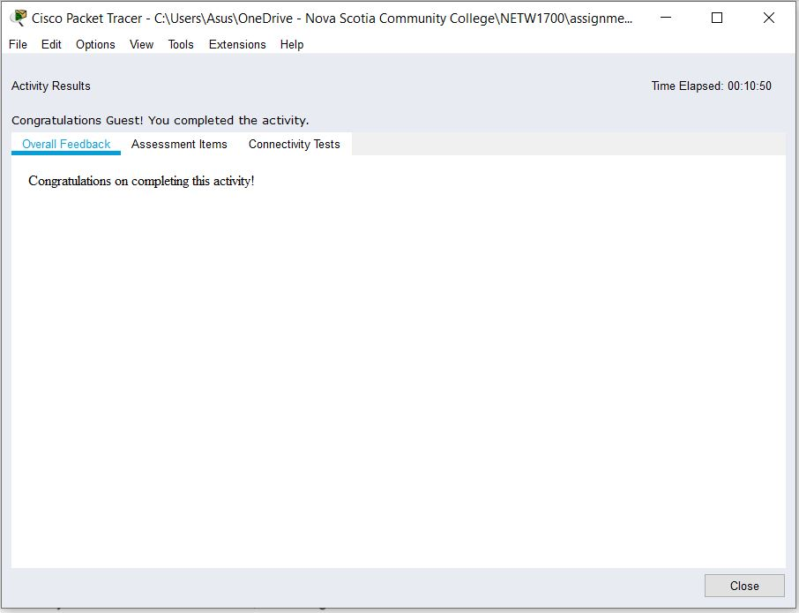

### Screenshot 1 of Activity 4 – Network Media Completion

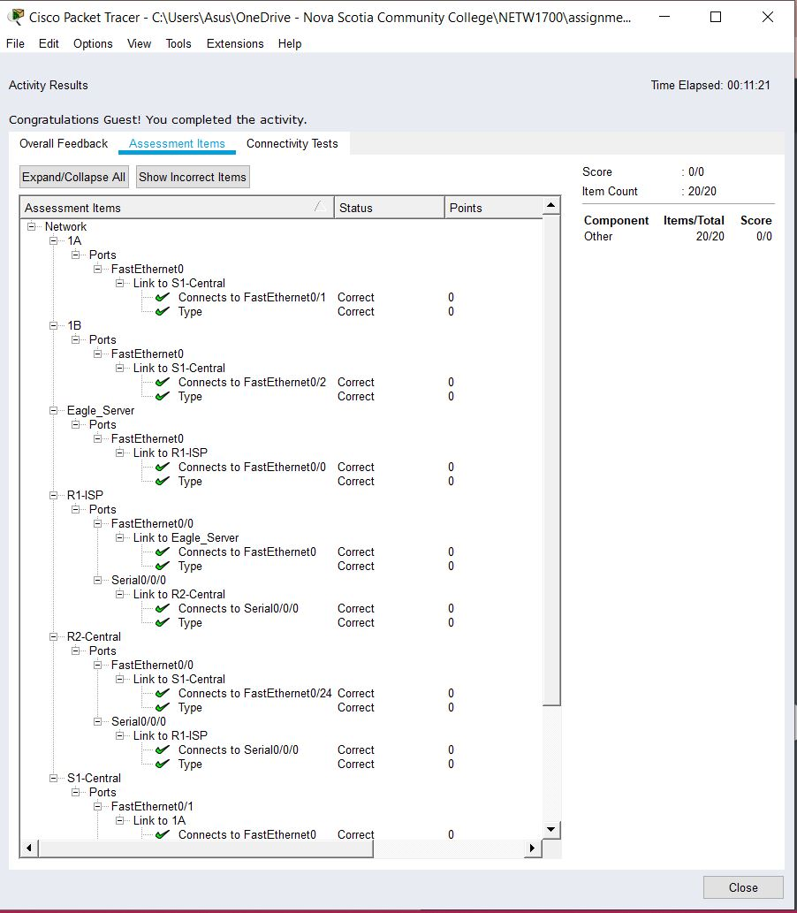

### Screenshot 2 of Activity 4 – Network Media Assessment Items

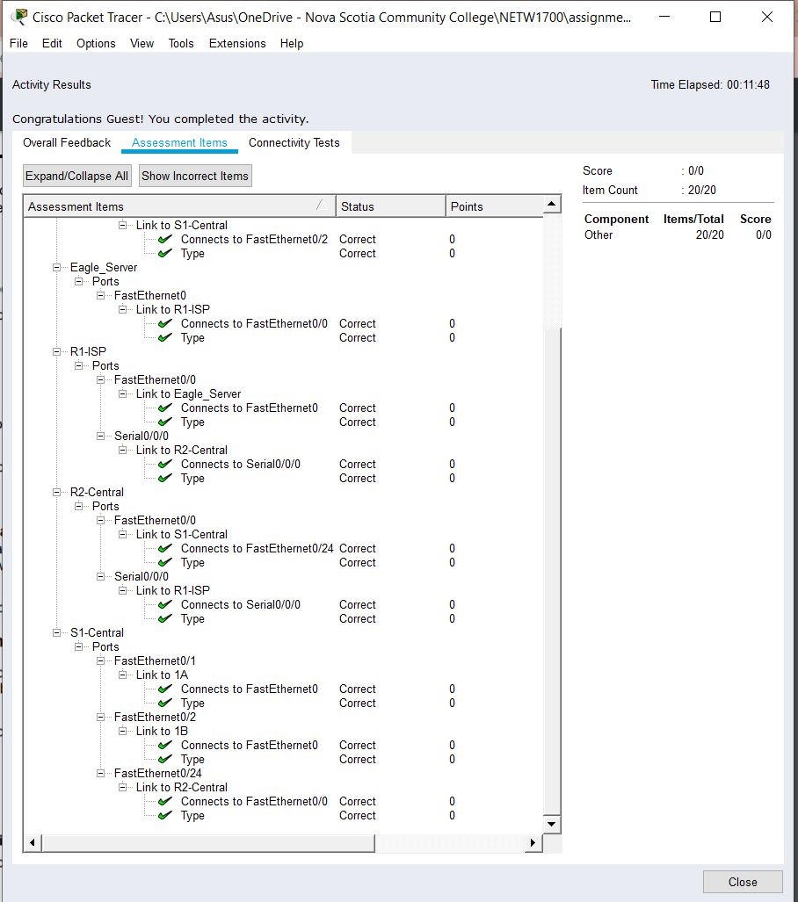

### Screenshot 3 of Activity 4 – Network Media Assessment Items

## Reflection:

### Do you know the difference between a physical topology and a logical topology? How are each used? How would you view each topology in Packet Tracer?

* The physical topology shows how the network is physically laid out. It is the actual physical placement of the devices. It shows the devices’ actual locations and physical set up. The logical topology shows the virtual connections made between each node of a network.
* The physical topology is used to show the actual physical location of the devices and infrastructure. The logical topology is used to show the network set up, the virtual connections made, and how data is being sent between devices.
* To view each topology in packet tracer, you would have to go to the top of the screen on the panel with the line colored blue (as shown in the figure below) and click on either Logical or Physical depending on which topology you would like to view. Another option is to type Shift + L to go to the logical topology or Shift + P to go to the physical topology.

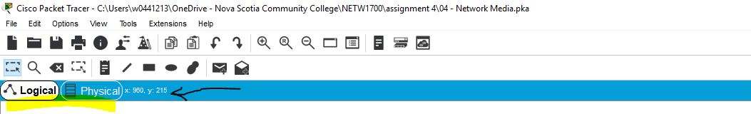

# References

Beal, V. (n.d.). *broadband*. Retrieved October 4, 2019, from Webopedia: https://www.webopedia.com/TERM/B/broadband.html

Cisco Networking Academy. (n.d.). *Introduction to Networks, Chapter 2: Configure a Network Operating System*. Retrieved October 2, 2019, from Cisco Networking Academy: https://static-course-assets.s3.amazonaws.com/ITN6/en/index.html#2

Cooper, S. (2018, December 13). *The diffference between, straight through, crossover, and rollover cables*. Retrieved from comparitech: https://www.comparitech.com/net-admin/difference-between-straight-through-crossover-rollover-cables/

DeLisle, J.-J. (2014, November 15). *What’s the Difference Between Broadband and Narrowband RF Communications?* Retrieved from Microwaves&RF: https://www.mwrf.com/sites/mwrf.com/files/styles/article_featured_retina/public/22qpromo.gif?itok=o3hI9xNm

Gui, A. (2016, December 21). *Difference of Straight Through and Crossover Cable*. Retrieved from Fiber Optic Cabling Solutions: http://www.cables-solutions.com/difference-between-straight-through-and-crossover-cable.html

Maxim Integrated. (2003, February 18). *An Introduction To Spread-Spectrum Communications*. Retrieved from Maxim Integrated: https://www.maximintegrated.com/en/design/technical-documents/tutorials/1/1890.html

Networks, I. (2015, July 27). *What is attenuation and how does it affect your network?* Retrieved from iTel: https://itel.com/what-is-attenuation/

Rosenberg, P. (1999, August 1). *The Basis of Datacom: Copper Media*. Retrieved from EC&M: https://www.ecmweb.com/content/basics-datacom-copper-media

Rouse, M. (2019, June). *Attenuation*. Retrieved from SearchNetworking.

Rouse, M., & Behmann, C. (2006, October). *Spread Spectrum*. Retrieved from SearchNetworking: https://searchnetworking.techtarget.com/definition/spread-spectrum

techopedia. (n.d.). *Narrowband*. Retrieved October 3, 2019, from Techopedia: https://www.techopedia.com/definition/8497/narrowband

Techopedia. (n.d.). *Spread Spectrum*. Retrieved October 4, 2019, from Techopedia: https://www.techopedia.com/definition/9509/spread-spectrum

Wikipedia. (2019, October 4). *Broadband*. Retrieved from Wikipedia: https://en.wikipedia.org/wiki/Broadband

Wikipedia. (n.d.). *Multiplexing*. Retrieved October 4, 2019, from Wikipedia: https://en.wikipedia.org/wiki/Multiplexing

Wikipedia. (n.d.). *Narrowband*. Retrieved 10 3, 2019, from Wikipedia: https://en.wikipedia.org/wiki/Narrowband

1. (Cisco Networking Academy, n.d.)
2. Answers referenced from: (Cisco Networking Academy, n.d.), (Gui, 2016) and (Cooper, 2018)
3. References from (Cisco Networking Academy, n.d.), (Networks, 2015), (Rosenberg, 1999) and (Rouse, Attenuation, 2019)
4. References from (Cisco Networking Academy, n.d.), (Wikipedia, n.d.) (techopedia, n.d.)
5. References from (Wikipedia, 2019) (Beal, n.d.)
6. Multiplexing is a method where multiple digital signals are combined into one signal over a shared medium. (Wikipedia, n.d.)
7. References from (Maxim Integrated, 2003), (Rouse & Behmann, Spread Spectrum, 2006), (Techopedia, n.d.)